VIKING PRESENTATION

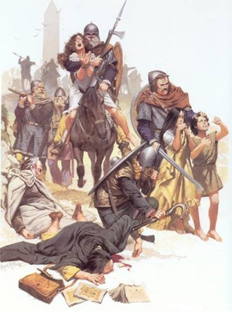
To go along with the many aspects of Viking Culture that we are covering, you will be required to create a presentation on a famous Viking. You will be able to choose 1 of the topics listed below.
Erik the Red
Leif Erikson
Viking Longships
Viking Weaponry
You will make your presentation using Google slides and it will be need to be at least 7 slides. The presentation will need to have at least 12 facts about your topic, along with illustrations and pictures. The Presentation will be a Quiz grade and will need to be presented to the entire class. You will work on this presentation in class using Chromebooks.
You can use the links at the bottom to help you, but you are not limited to them.
http://www.enchantedlearning.com/explorers/page/e/ericthered.shtml
http://www.biography.com/people/erik-the-red-9288270
http://www.history.com/topics/exploration/leif-eriksson
http://www.bbc.co.uk/history/historic_figures/erikson_leif.shtml
http://www.bbc.co.uk/schools/primaryhistory/vikings/vikings_at_sea/
http://www.thevikingmuseum.com/viking-longships.html
http://www.bbc.co.uk/history/ancient/vikings/weapons_01.shtml

